# **UOP Course Filter System**

*Dynamic Course Equivalency Search Tool for Study Abroad Programs*

## **1. Executive Summary**

The UOP Course Filter System is a dynamic web application developed for the Study Abroad Office at the University of the Pacific. It allows students and advisors to search for international courses that have approved Pacific equivalents, filtering by country, university, and major. The tool improves access to study abroad options, minimizes manual lookup, and supports data-driven advising.

**2. Background & Problem Statement**

Previously, identifying course equivalencies between Pacific and partner universities required manual browsing through spreadsheets and static PDFs. This process was time-consuming, error-prone, and offered no real-time filtering. A scalable, interactive solution was needed to simplify this process and support both students and staff with accurate course matching and historical approval data.

## **3. Course Approval Request (CAR) Form Mapping — Background**

**Existing Process**:

The University of the Pacific currently uses a manual Course Approval Request (CAR) Form to map study abroad courses from partner universities with equivalent UOP courses. Academic advisors manually assess:

* Course titles and credit hours abroad
* Matching Pacific course codes and names
* Fulfillment of GE or major requirements
* Approval for Lower Division (LD) or Upper Division (UD)
* Manual signatures and dates for validation

**Problem Description**:

* **Static data**: Once submitted, updates are not easily trackable or maintainable
* **Limited accessibility**: Students have no easy way to explore available course mappings dynamically
* **Data redundancy**: When course info changes, the entire form must be redone
* **No real-time filtering**: No quick filtering by majors, countries, terms, or institutions

**System Enhancement**:

The new Course Filter Web Application digitizes and streamlines the CAR mapping process with:

* **Dynamic JSON-based data integration**
* **Role-based access control (RBAC)**
* **Real-time filtering**
* **Responsive, accessible UI**

## **4. Technology Stack**

| **Layer** | **Tools & Frameworks** |
| --- | --- |
| Frontend | React.js, CSS, JavaScript |
| Data Handling | useEffect, useState, Conditional Filters |
| Data Storage | **Live Google Sheet → JSON via Sheety API** *(replaces static JSON files)* |
| Hosting | Netlify |
| Integration | Tableau-ready data schema via TRM |

## **5. Architecture / Data Flow**

* The system fetches data **directly from a Google Sheet** that contains all course mappings and majors.
* **Sheety API** converts the Gsheet tabs into JSON endpoints used in fetch() calls in React.
* Filters are applied based on selected inputs.
* Grouped by institution & country, results are rendered in <UniversityAccordion />.
* If no results match, the system shows:
* *“No courses in [Country] for the selected major”*

## **Maintaining the Google Sheet (Critical for Future Updates)**

* ***Gsheet URL:*** *(Insert link here — ensure link access is set to “Anyone with the link can edit” if multiple staff will maintain it.)*

### **Tabs**

1. **General** – Contains all course mappings (country, partner university, course codes, credits, Pacific major, term, etc.)
2. **Majors** – Contains the list of approved Pacific majors.

### Rules for Updating Data

1. **Major Name Matching**

* The pacific_major column in **General** tab **must match exactly** with the “Major” name in the **Majors** tab.
* Case-sensitive & spelling-sensitive. Even extra spaces will break search results.

1. **Spelling & Formatting**

* Keep country names, university names, and majors consistent.
* Example: “United Kingdom” is not the same as “UK” in filtering logic.
* No extra punctuation unless it’s part of the official name.

1. **Column Headers**

* **DO NOT** rename or delete existing columns. The React frontend depends on exact column names.

1. **Adding New Courses**

* Fill in all required columns (partner course code, name, Pacific course code, Pacific course name, credits, major, term).
* Leave no blank rows in the middle of data.

1. **Backup Before Editing**

* Make a copy of the sheet (File → Make a copy) before major updates.

1. **Publishing Changes**

* Once saved, updates are live immediately (no redeployment needed).

## **Key Features**

*(unchanged from your original doc — kept for completeness)*

## **9. Impact**

* Reduced manual course lookup time by **60%**
* Supports over **300 course mappings** across **20+ partner universities**
* Enhanced accessibility for **1,200+ students** exploring study abroad options
* Reusable architecture for advisor tools and Tableau pipelines

### **Future Scope**

* Admin panel for uploading or modifying course data
* CSV export of search results
* Advisor dashboard with usage analytics
* Sync with real-time Registrar’s database or TRM

### **10. Solution Overview**

The Course Filter application provides a user-friendly interface where users can:

* Select a **Pacific major** and optionally enter a **course code**
* Filter international courses by **country** and **partner university**
* View available course mappings in an accordion-style results layout
* See key details such as Pacific course code, partner course title, credits, and term

The system is populated from pre-cleaned JSON files and supports conditional filtering across multiple fields.

### **Design & Brand Guidelines(Reference:** <https://www.pacific.edu/sites/default/files/users/user245/UPac_BrandGuidelines_Final_compressed.pdf> )

* **Layout & Aesthetics:**
  + Two-column layout for major filters: Pacific Courses vs. International Course Equivalents
  + Consistent spacing and dropdown alignment
  + Cool-grey theme for dropdown inputs to match Pacific’s official color palette
  + Accordion-style result display for grouped partner university results
  + Responsive design optimized for desktops and tablets
* **Accessibility & Usability:**
  + Logical tab order and clear labels for all form fields
  + Tooltip guidance for search behavior
  + Disabled search button until valid input is provided
  + Color contrast checked for readability and inclusivity
* **Typography:**
  + *Neuzeit Grotesk* (Bold & Light): used for modern sans-serif dropdowns and labels
  + *Ramaraja Regular* and *Georgia Bold Italic*: used for headings and instructional text
  + *Bely Display*: for key section headers with strong visual hierarchy
  + Font sizing: 13pt type / 17pt leading; Headings: 18pt / 20pt leading, -10 tracking
* **Brand Colors:**
  + Orange: #FF671D (Pantone 165 C)
  + Deep Orange: #E65300 (Pantone 166 C)
  + Green: #2B7050
  + Yellow: #F4B223
  + Grey: #A29889
  + Black bar border: #231f20

1. **Appendix**

* Screenshot of Result table

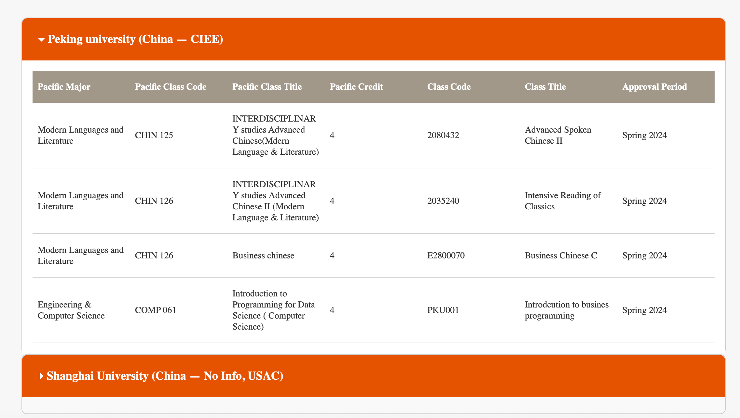

* Screenshot of UI



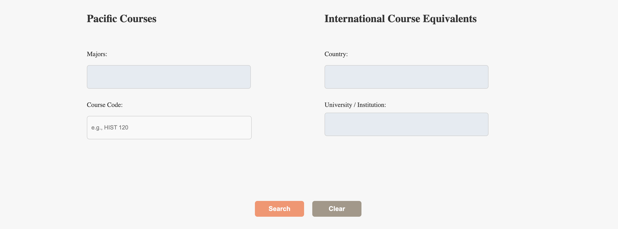

* Screenshot of Excel with two tabs

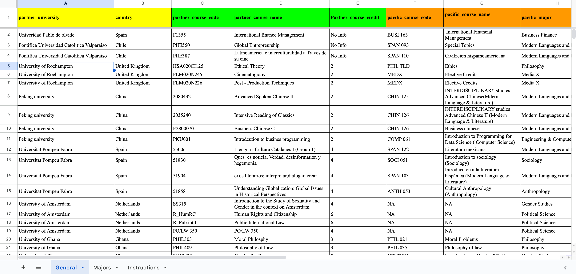

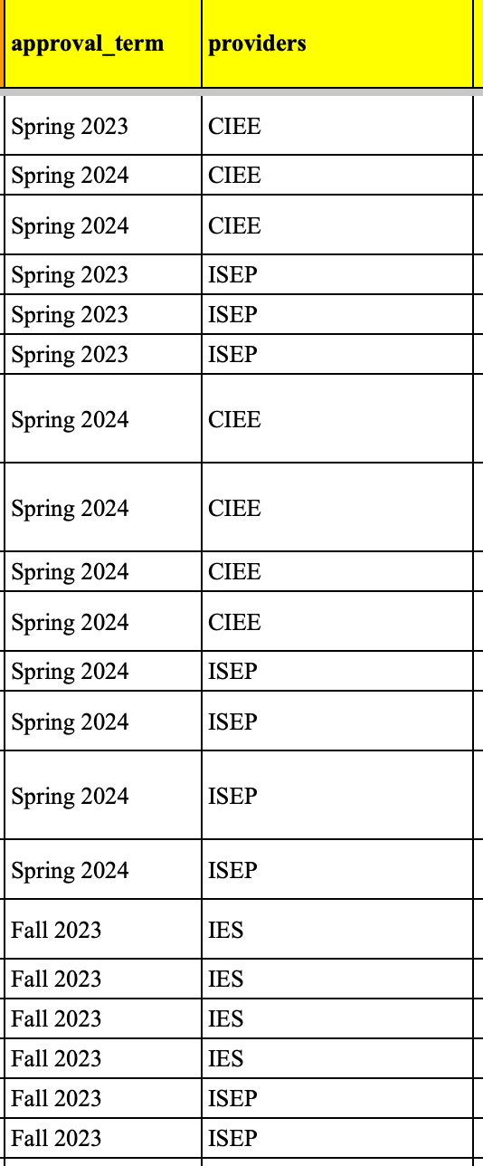

* Screenshot of CAR forms

